Kindergarten Supply List

1. Backpack
2. Change of clothes in a bag to be left in their cubby (just in case).
3. Water Bottle
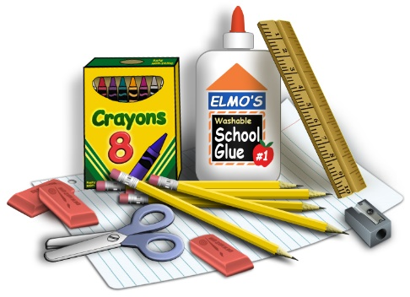
4. Headphones (no ear buds or blue tooth please)
5. Glue sticks
6. Crayons
7. Pencils
. Scissors

Classroom Wish List Items- Thank you for any donations

White Board Markers
Markers
Sanitizing wipes (Clorox or Lysol)
Kleenex
Ziploc Bags (any size)
Paper Towels
Snacks (pretzels, goldfish, graham crackers, fruit snacks, cereal bars, popcorn, rice krispy treats…)

